**ROHITH RAJAGOPALAN**

**1001518031**

[**2208-CSE-5382-001**](https://uta.instructure.com/courses/62497)

**Assignment 9: SQL Injection Attack**

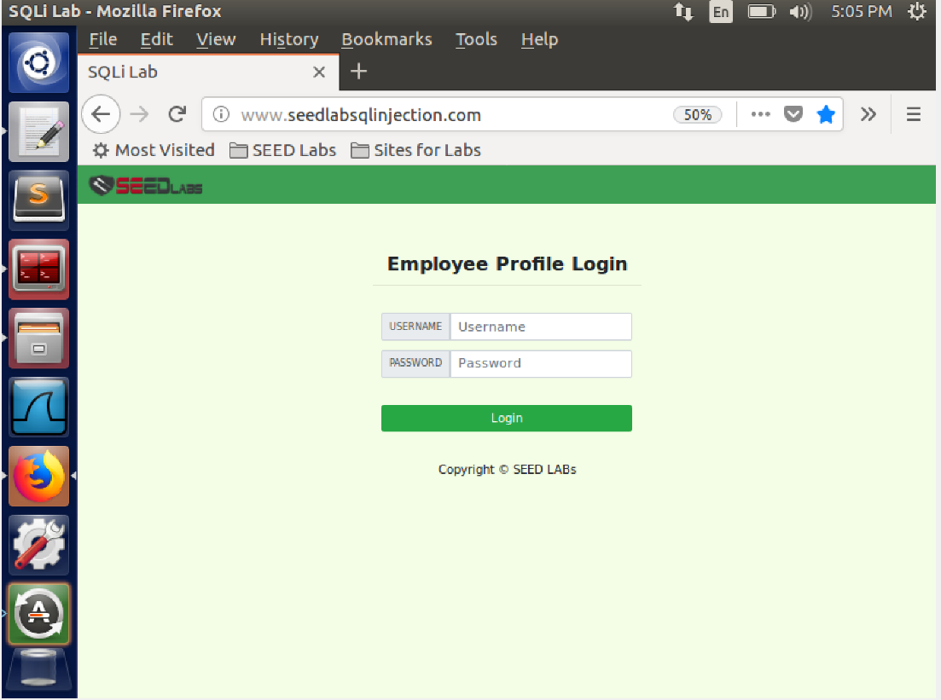

This is the website we will be using to demonstrate our lab exploits.

**Task 1: Get Familiar with SQL Statements**

In this task we try and get familiar with SQL commands. First we log into mysql database and then we use the show databases command to see the available databases. We then use show tables to see the available tables. We are going to work on the table called credential.

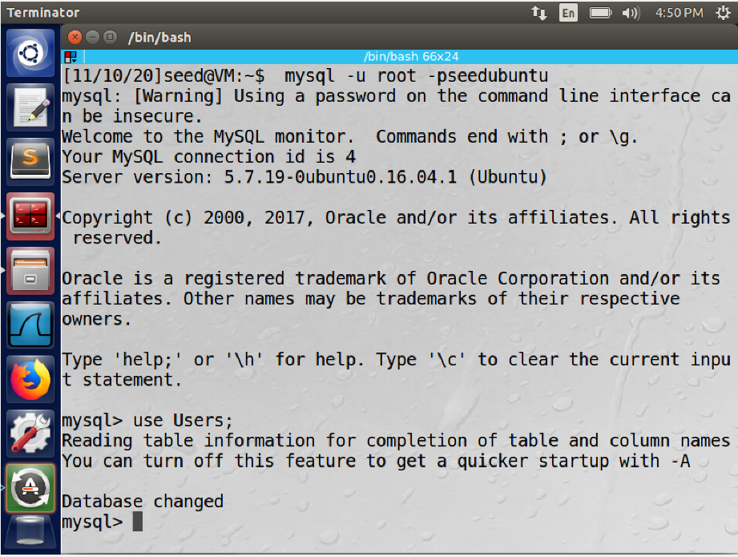

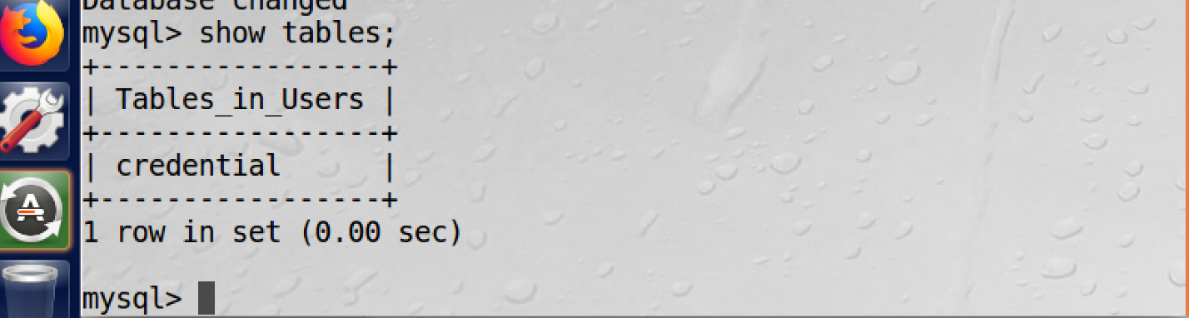

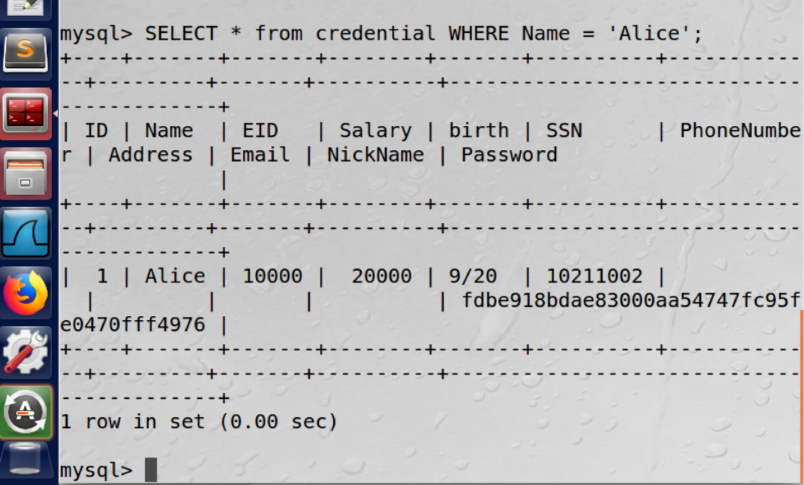

**Task 2: SQL Injection Attack on SELECT Statement.**

We perform SQL injection attacks on the SELECT statement in this task

**Task 2.1: SQL Injection Attack from webpage.**

In this task we try to exploit the sql injection attack from the webpage. We enter the username as admin but assume that we do not know the password. So we put a "#" sign after the name. Ie name=Admin,'#'. From the images we can see that we get access to the database with admin account and can see the details of all the employees. This happened because the everything after the # is commented out and thus the password field as well. Hence we get access to the data.

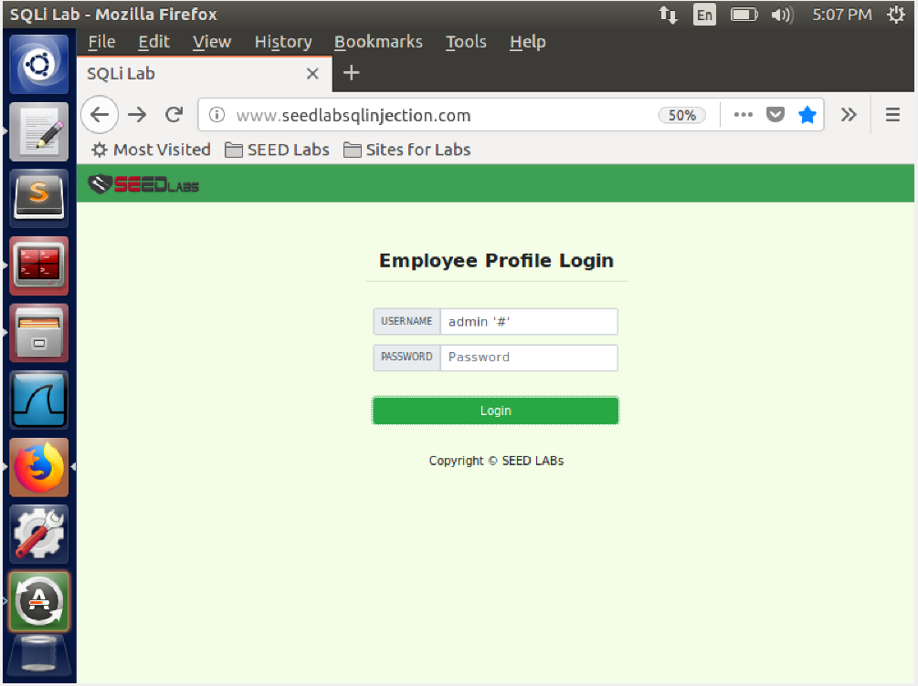

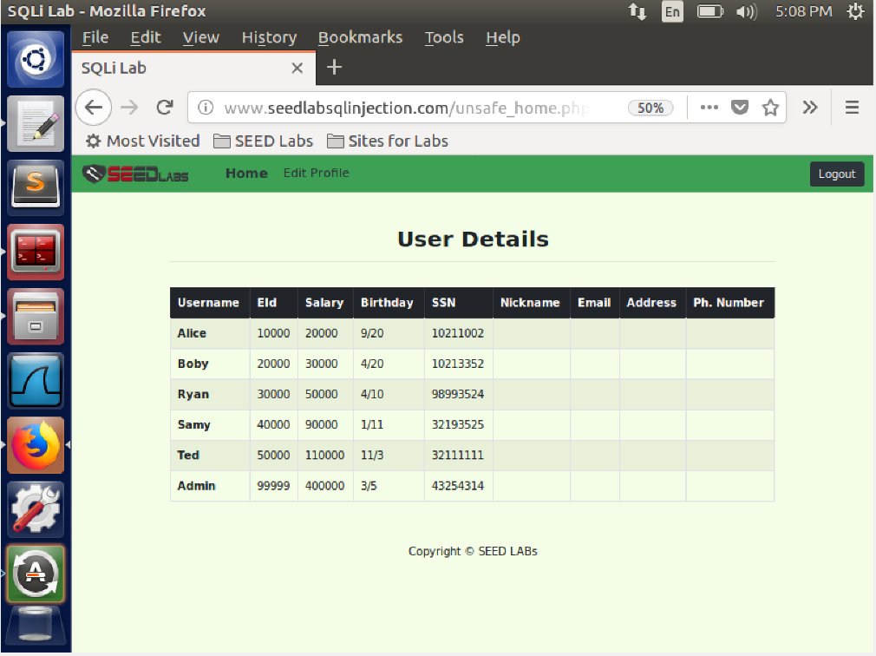

**Task 2.2: SQL Injection Attack from command line.**

In this task we try to exploit the sql injection attack using the command line terminal. We do the same procedure as the previous task and capture it using LiveHTTPheaders, we then get the link for the login attack and we attach it to the curl command as shown in the image. We can see that we have got the data from the database in form of a table in our terminal

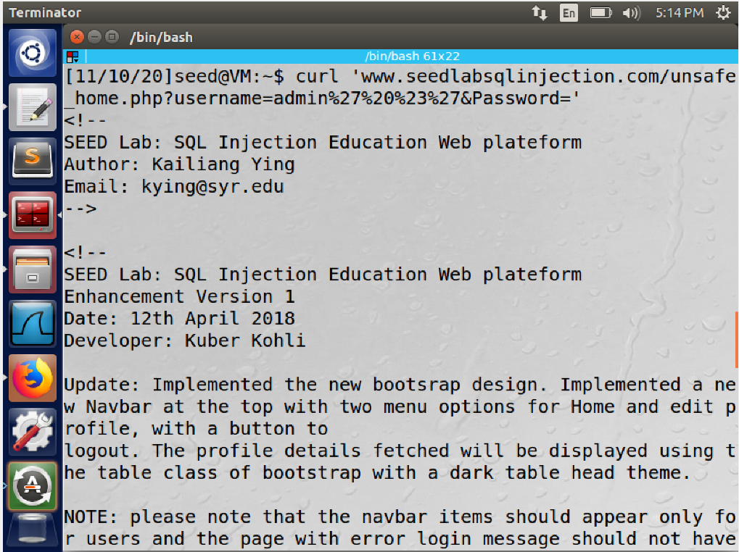

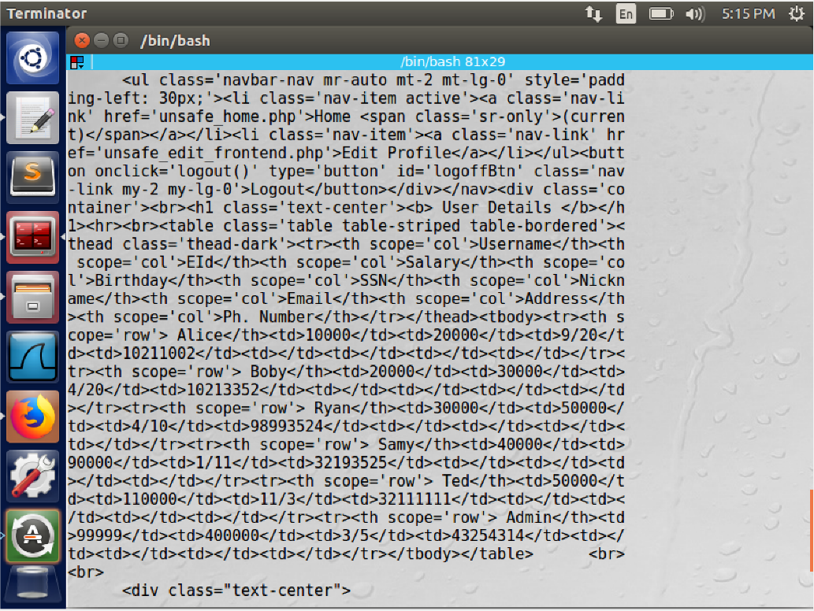

**Task 2.3: Append a new SQL statement.**

In this task we try to append multiple sql statements using the semicolon and carry out the attack(either update or delete). we can see that the attack is not successful, this is because even though our website is vulnerable to sql injection attack my sql has countermeasures enabled that prevent multiple sql statements from being invoked in a single command. We also try to exploit the attack using the command line but that fails as well. The above attack doesn't work. Because in phps mysql I extension, the mysqli::query() api doesn't allow multiple queries to rub in the db server.

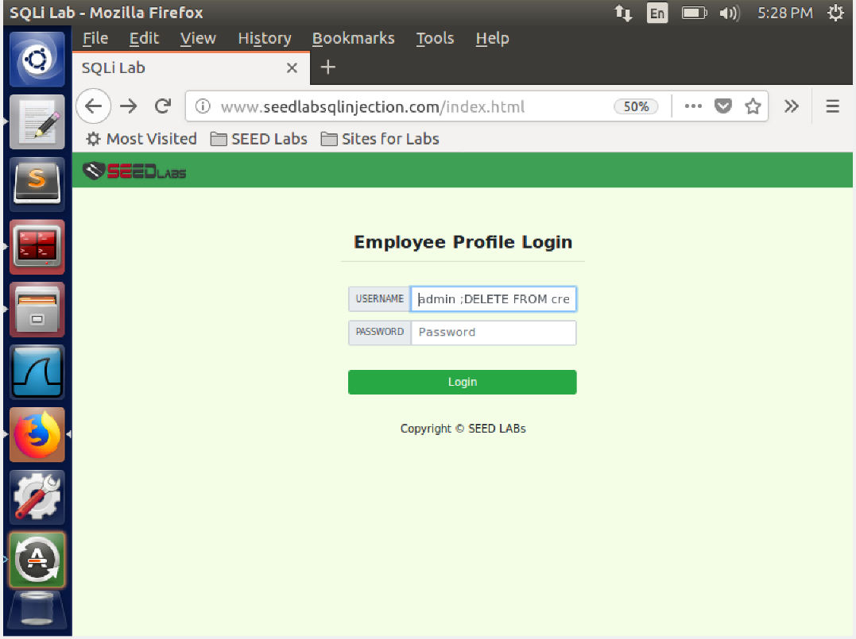

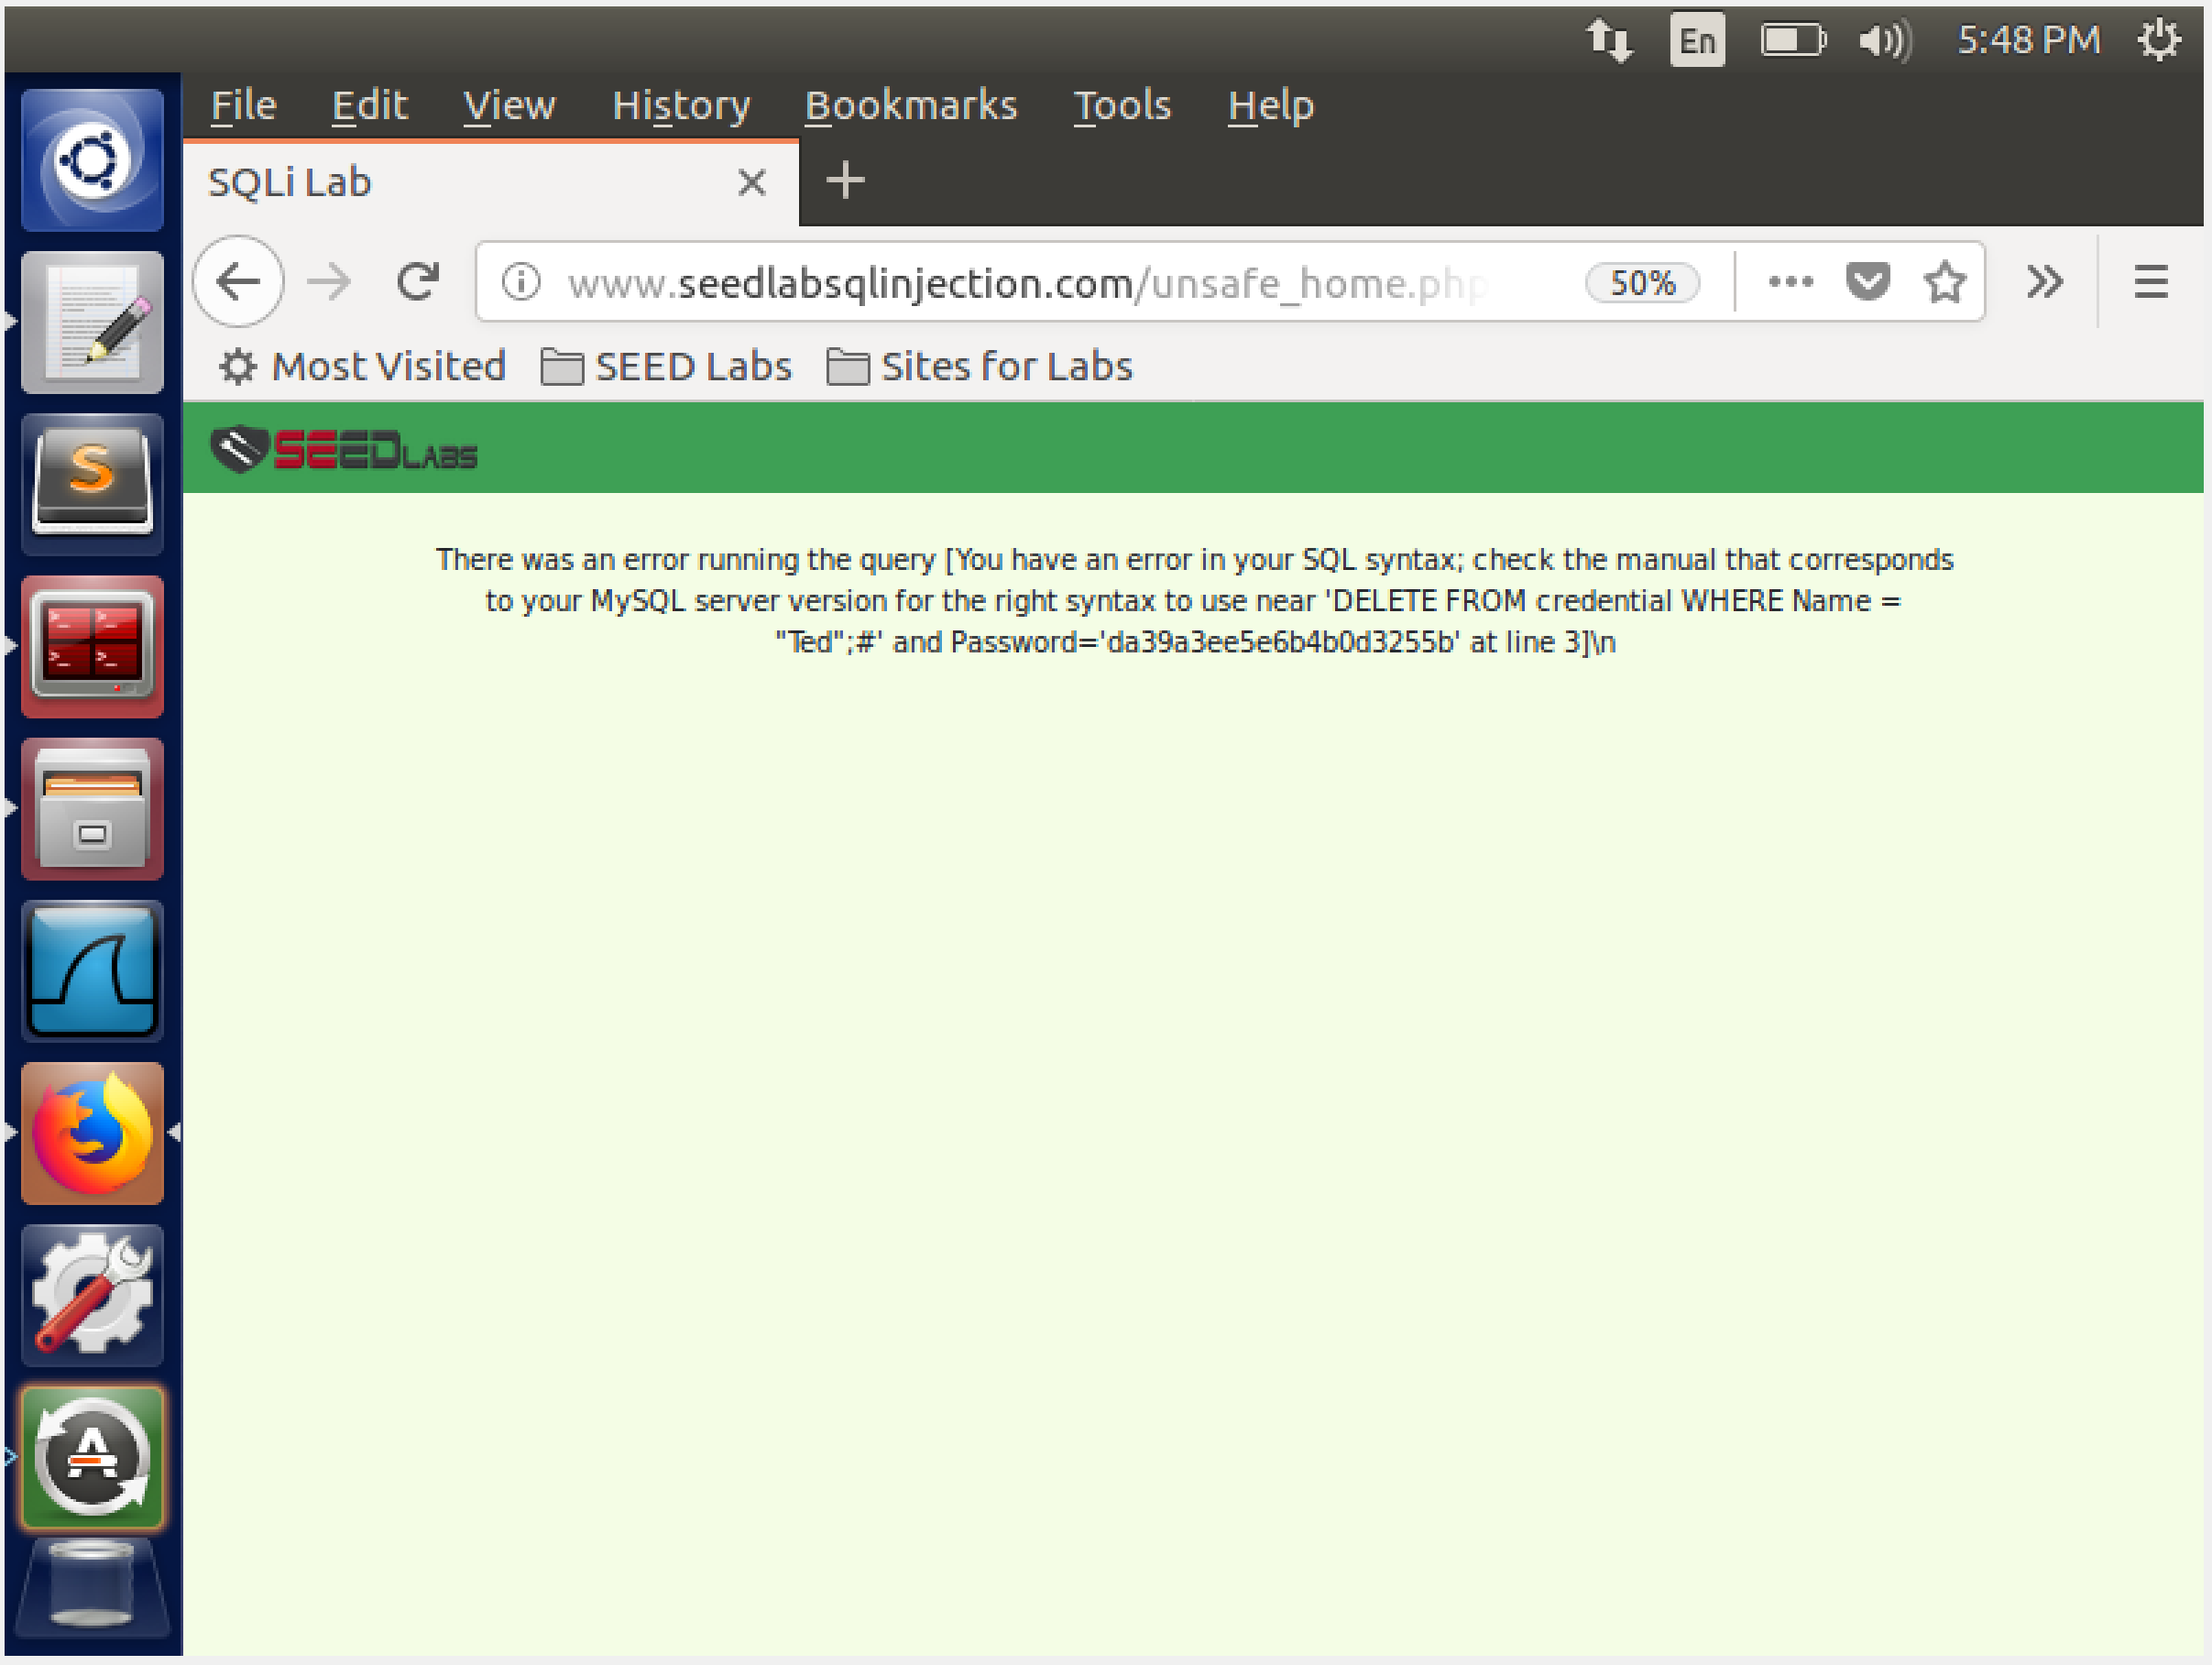

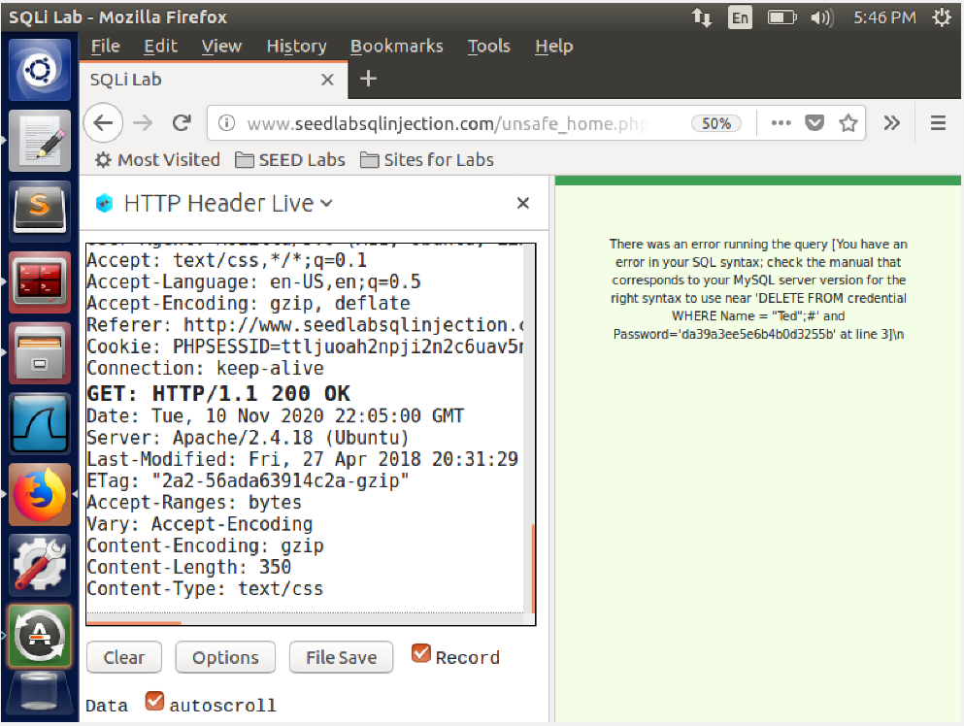

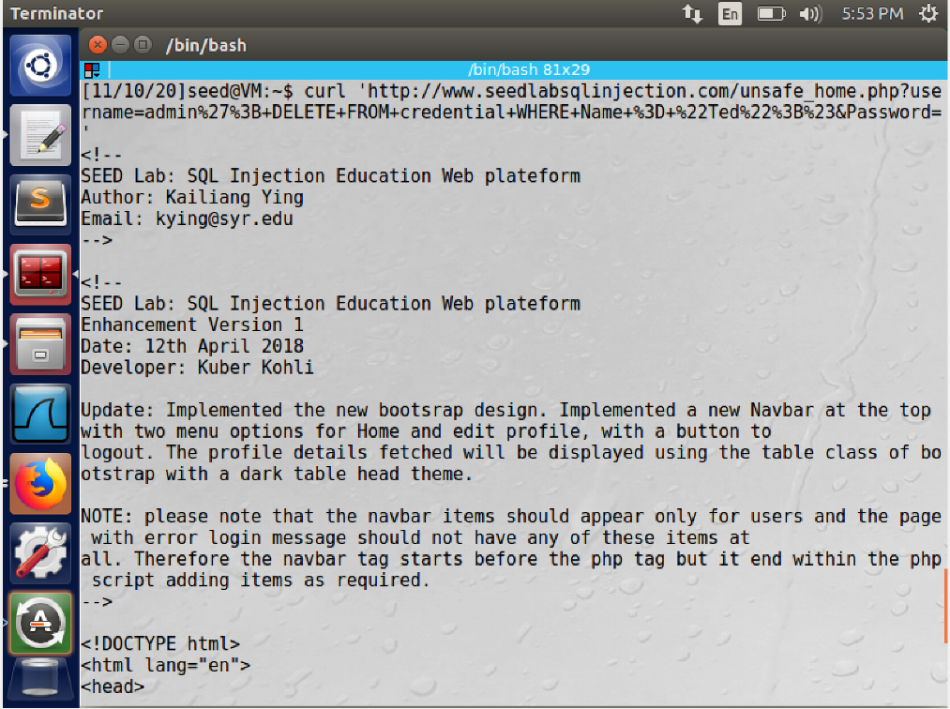

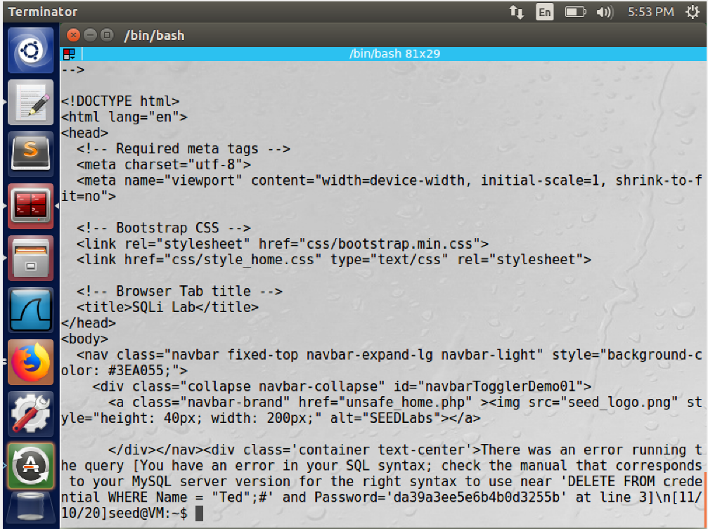

**Task 3: SQL Injection Attack on UPDATE Statement**

In this task we try to exploit the update statement with the SQL injection attack

**Task 3.1: Modify your own salary**

In this task we modify Alice's salary, we log in as Alice and enter our query to modify Alice's salary in her phone number tab. We then save and refresh the page. We realize that the query has been executed and Alice’s salary has been modified to a value set by us. To confirm the attack we check the database too if the changes have been made

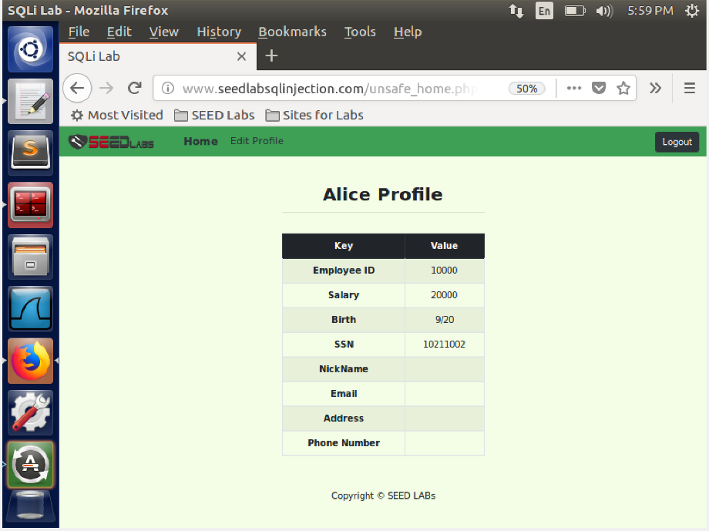

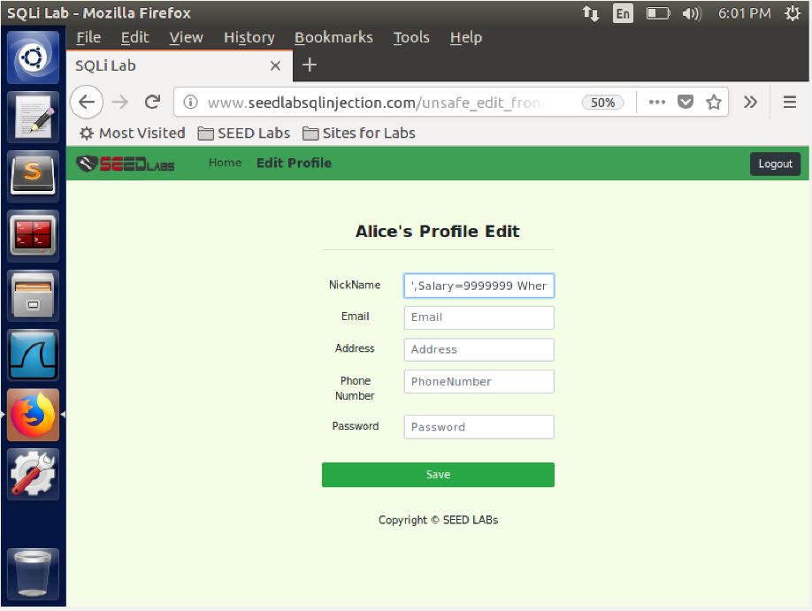

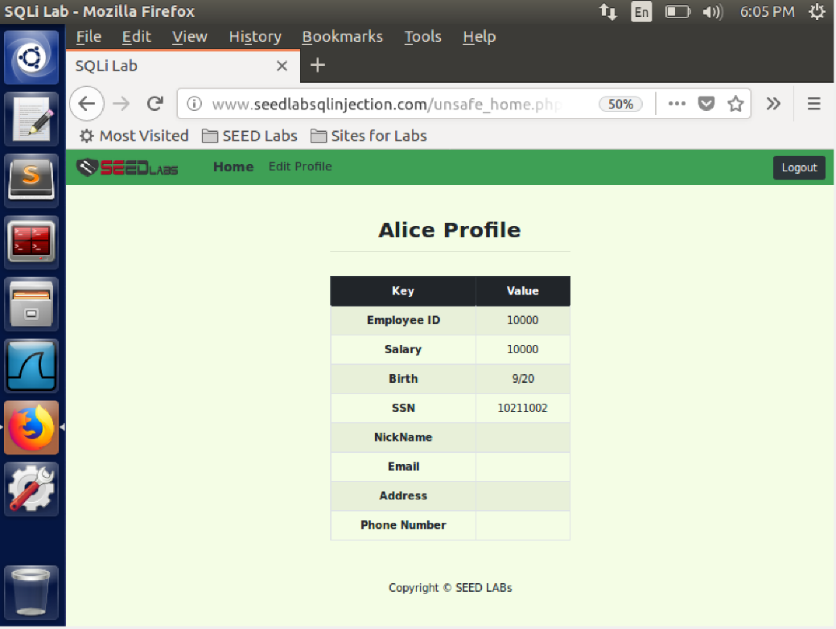

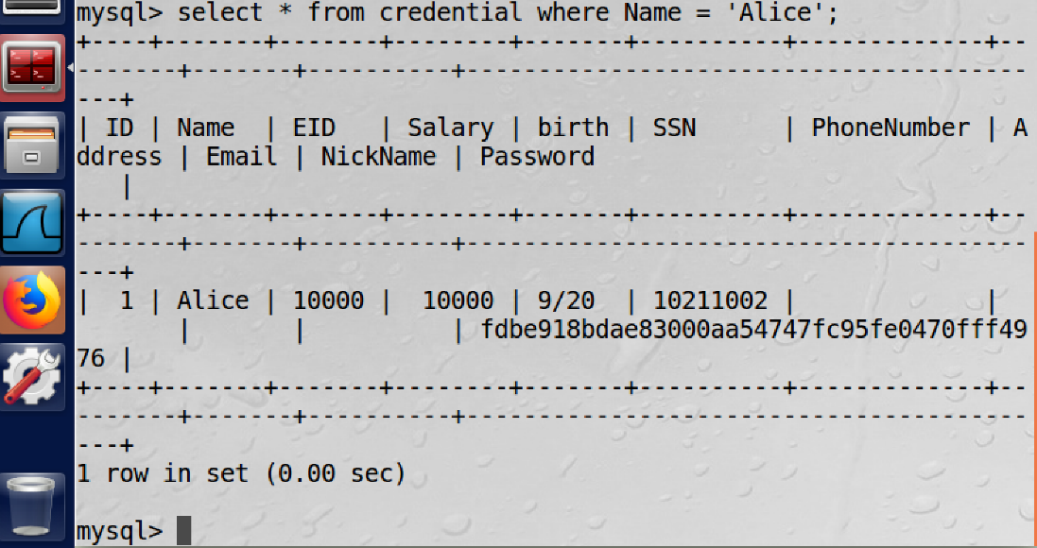

**Task 3.2: Modify other people’ salary.**

In this task we modify other people's salary. We choose bob as the target and enter the same query as the previous attack except that we add a where clause here with name='Boby' followed by an #. We observe that baby’s salary has been edited. To confirm the attack we check the database too if the changes have been made

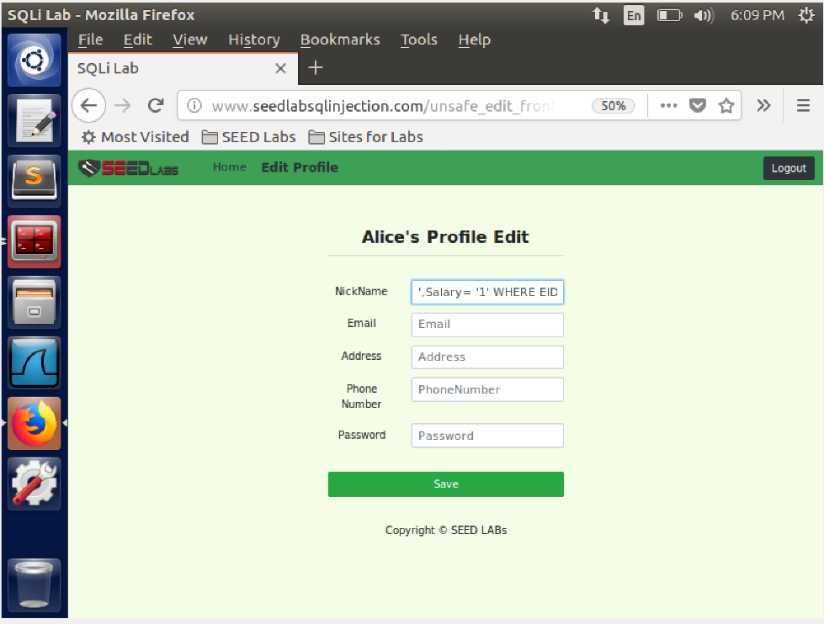

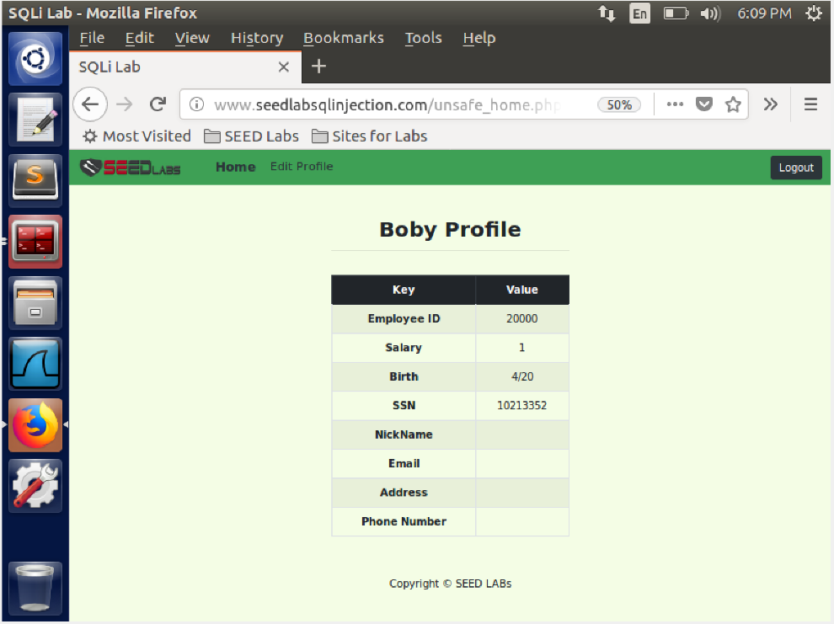

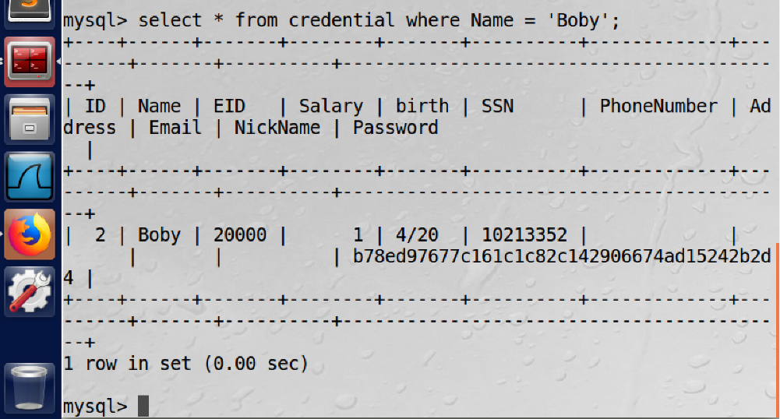

**Task 3.3: Modify other people’ password**

In this task we attempt to change bobys password. We enter the required query followed by an #. On saving the changes and living into bobys account we notice that his password had changed. We try to login with the old password and it's unsuccessful as shown. We try again with our updated password. We are successful, Thus this shows that our attack is successful

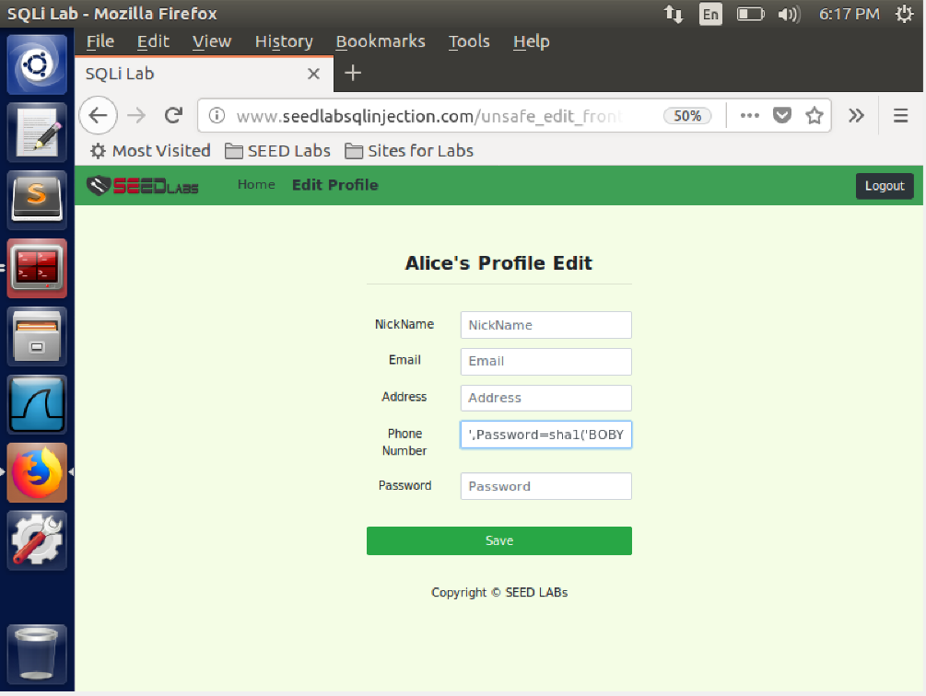

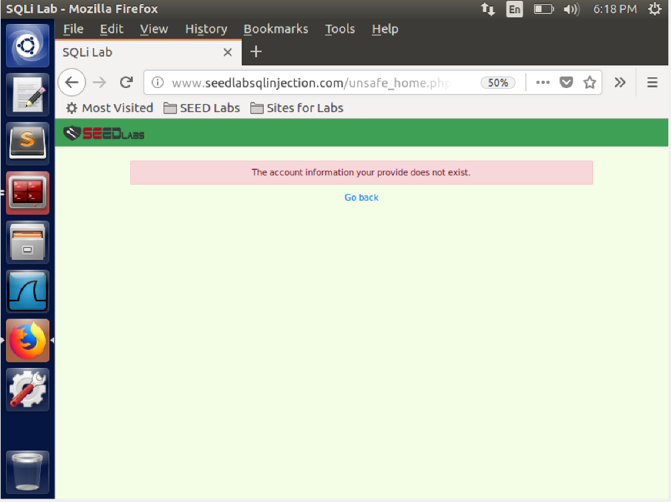

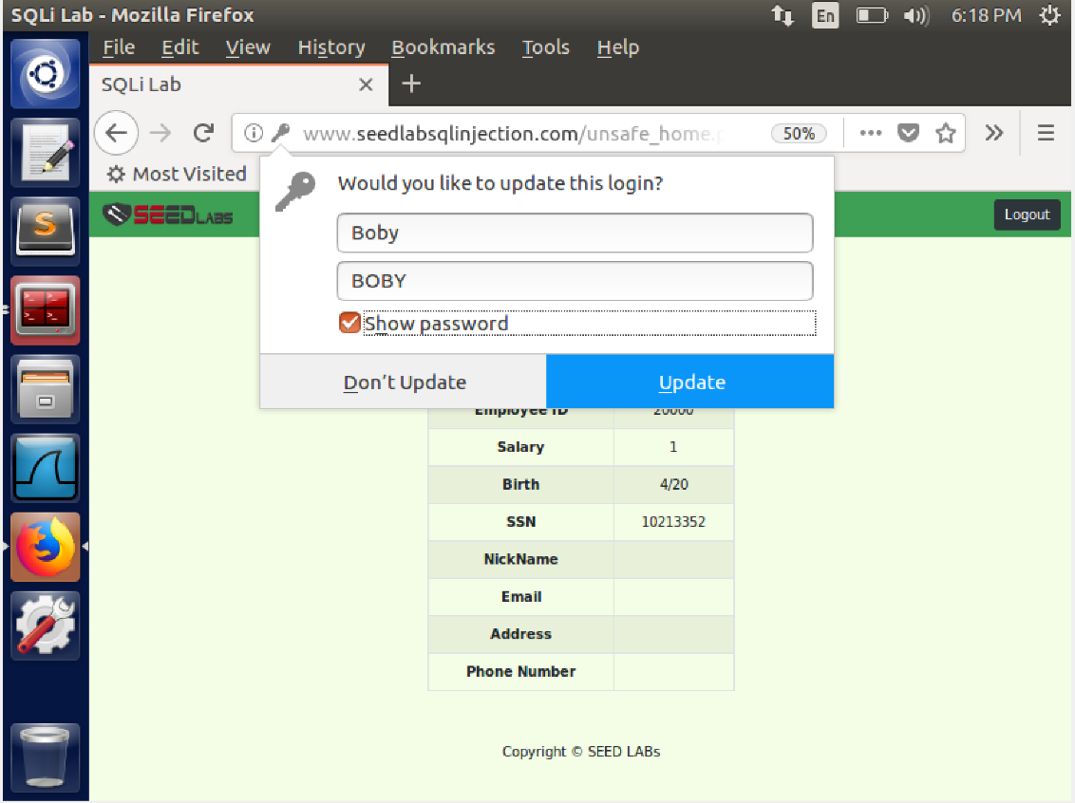

**Task 4: Countermeasure — Prepared Statement**

In this task we fix the vulnerabilities. We rewrite the sql statements in unsafe_home.php as shown in the image using prepared statements. We see that if we try task 2.1 after this the attack is unsuccessful. The error says that there is no user with credentials admin'# and password admin

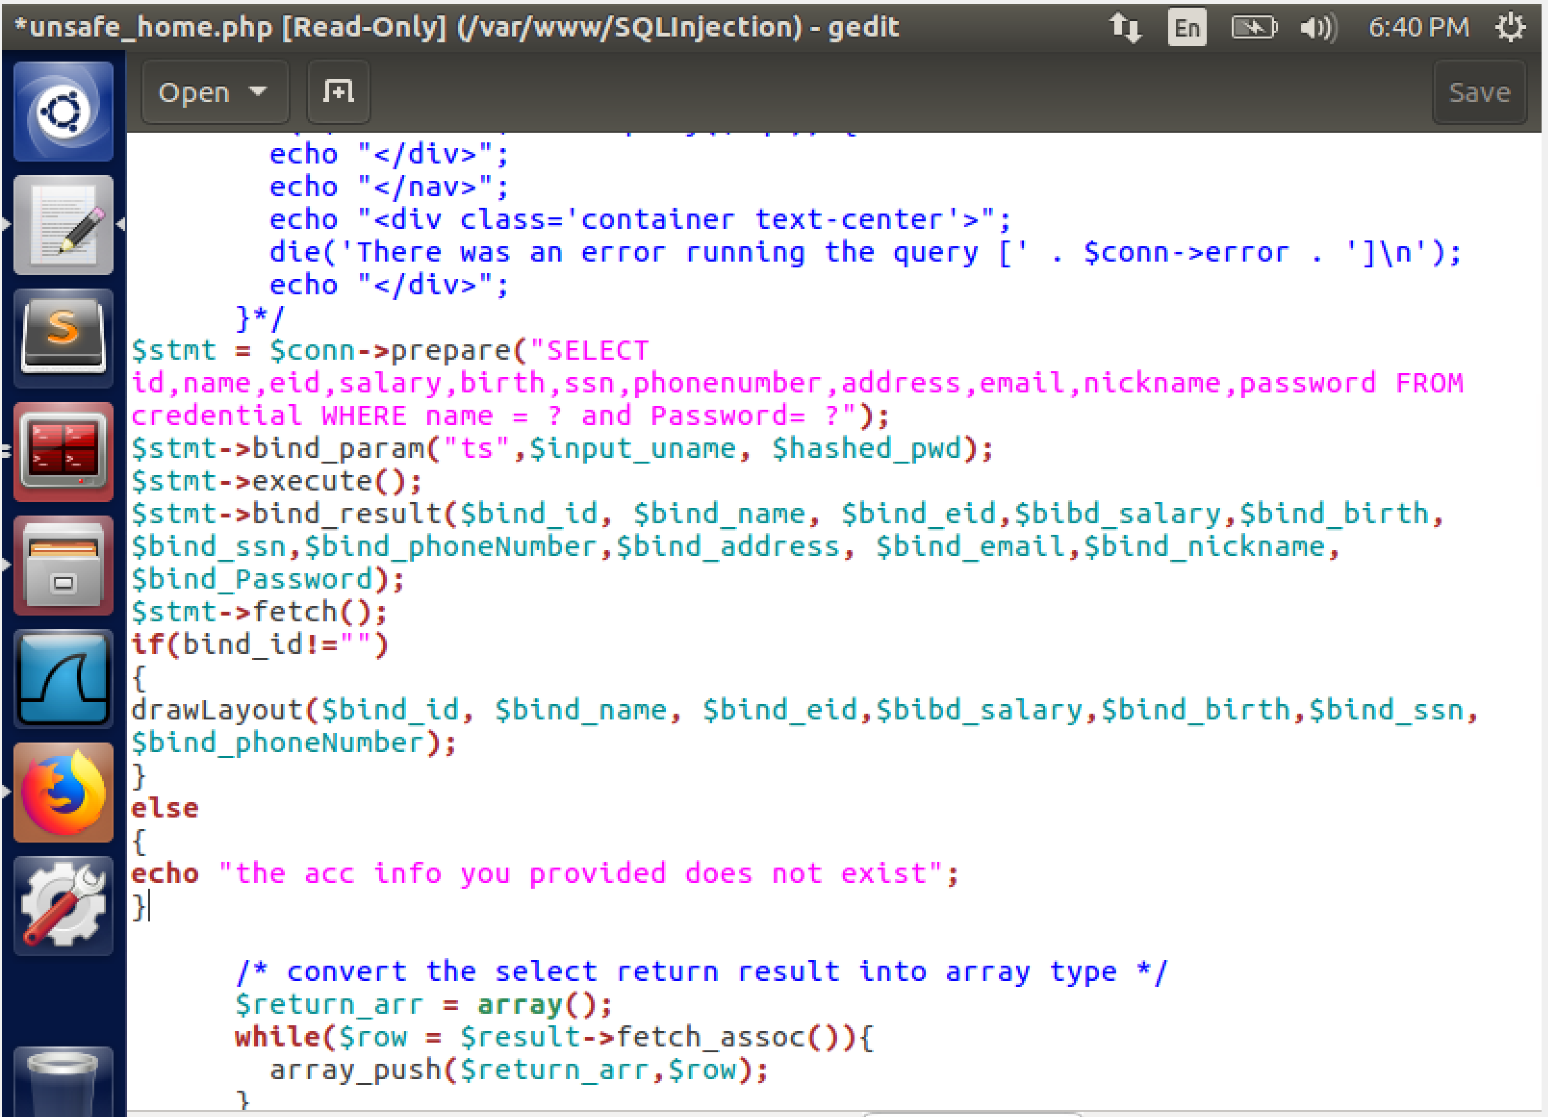

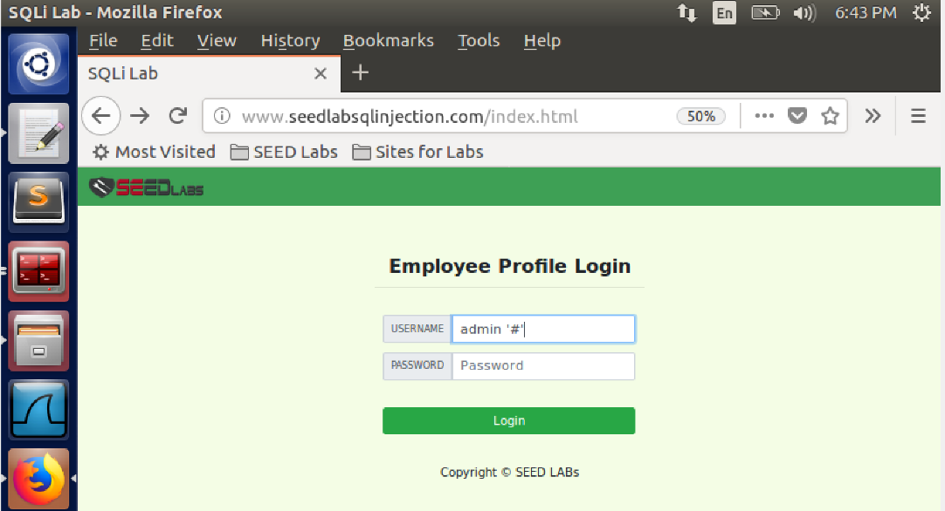

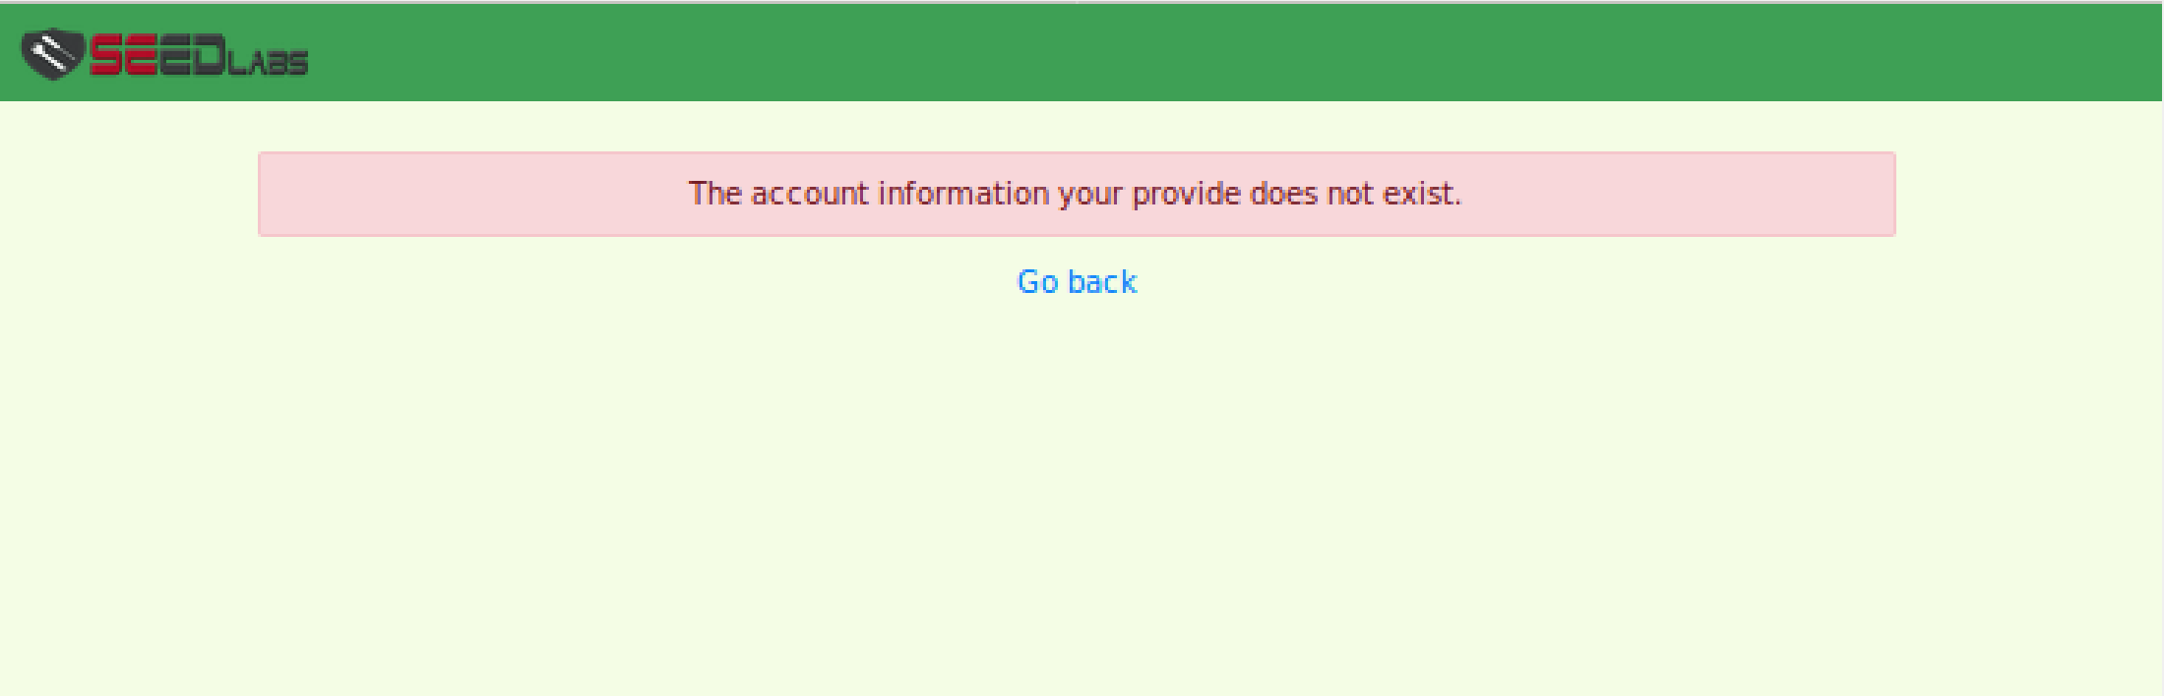

We then edit the unsafe_edit_backend.php and it is rewritten as follows.

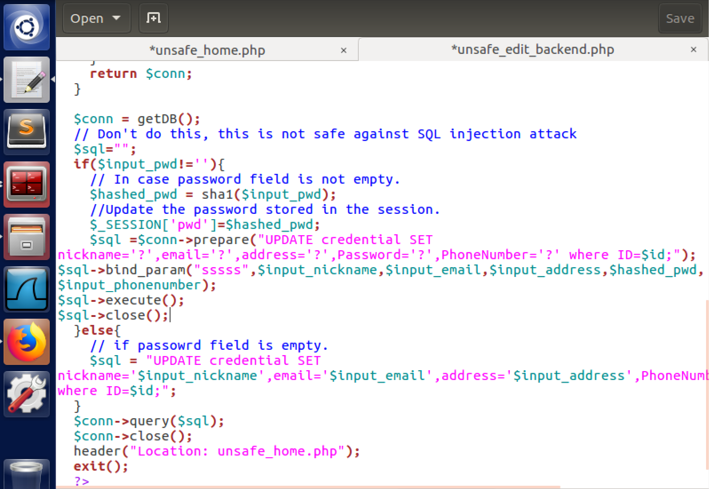

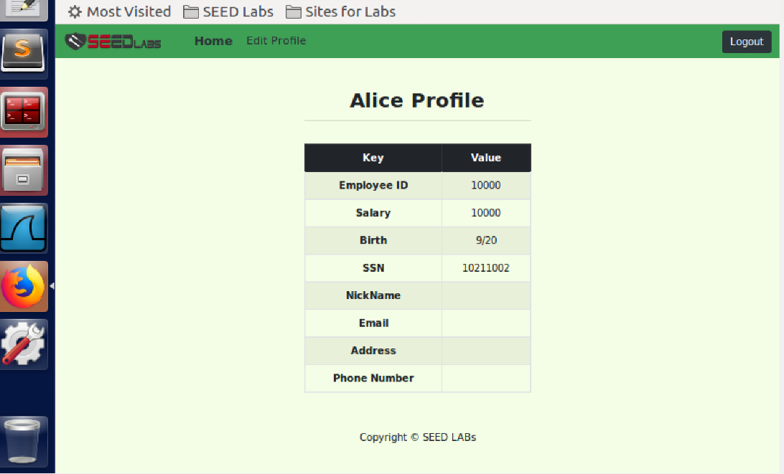

On executing the exploit for task 3.1 we see that the changes are not successful